FACTOR MODELS
Decomposing Returns into the Systematic Drivers of Risk and Reward
The Building Blocks of Modern Quantitative Portfolio Management
A Level 2 module in the Quantitative Finance Curriculum
Covers: single-factor models (CAPM) · multi-factor models · macroeconomic, fundamental & statistical factor models · Fama-French three-, four- and five-factor models · factor exposures & regression estimation · risk decomposition · smart beta & factor investing · factor crowding and factor timing

Table of Contents
How to Use This Guide
What You Need to Know Before Starting
Understand Before Proceeding
Why It Matters
How This Connects to the Rest of the Curriculum
Glossary of Recurring Terms
Part 1 — What Is a Factor Model?
1.1 The Intuition: Common Drivers Behind Many Returns
1.2 The Single-Factor Model: CAPM as the Starting Point
1.3 From One Factor to Many: The General Multi-Factor Model
Part 2 — Three Families of Factor Models
2.1 Macroeconomic Factor Models
2.2 Fundamental (Cross-Sectional) Factor Models
2.3 Statistical Factor Models
Part 3 — The Fama-French Tradition and the Factor Zoo
3.1 The Fama-French Three-Factor Model
3.2 Momentum and the Carhart Four-Factor Model
3.3 The Fama-French Five-Factor Model and the ‘Factor Zoo’
Part 4 — Estimating and Using Factor Models
4.1 Estimating Factor Exposures via Regression
4.2 Risk Decomposition: Factor Risk vs. Idiosyncratic Risk
4.3 Applications: Portfolio Construction, Hedging, and Attribution
Part 5 — Factor Investing in Practice
5.1 Smart Beta and Factor Investing
5.2 Factor Crowding, Timing, and Cyclicality
5.3 Pitfalls: Overfitting, Multicollinearity, and Data Mining
Practical Exercise
Common Beginner Mistakes
Advanced Extensions
Professional Applications
Where to Go Next

How to Use This Guide
This document introduces Factor Models, one of the foundational tools of modern quantitative portfolio management and risk analysis. A factor model explains the return on an asset — a stock, a bond, a portfolio, even an entire hedge fund — as the sum of its sensitivities to a small number of common, systematic drivers, plus whatever is left over that is specific to that asset alone. Factor models are the mathematical language in which nearly all modern asset pricing, risk management, and portfolio construction is written.
This module builds from the simplest possible factor model — a single factor, the market itself — up through the multi-factor models used by working risk managers and portfolio managers today. Each section follows the same pattern: the intuition first, then the formal mathematics, then a worked numerical example, then a figure, and finally a discussion of where the idea is used in practice and where it can go wrong. Read the module start to finish for the complete picture, or use the Table of Contents to jump to a specific factor family — but do not skip Understand Before Proceeding below.

What You Need to Know Before Starting
- Basic statistics — mean, variance, covariance, and correlation; a factor model is, at its core, a statement about how the covariance of returns is structured.
- Linear regression — ordinary least squares (OLS), the idea of a slope coefficient, and R²; factor exposures ("betas") are regression coefficients, and estimating a factor model is, in the most common case, literally running a regression.
- Portfolio theory basics — expected return, portfolio variance, and diversification, as covered in an introductory Modern Portfolio Theory module; factor models are, historically and conceptually, a direct extension of the Capital Asset Pricing Model (CAPM).
- A little linear algebra — comfort with the idea of a vector of exposures and a matrix of covariances is helpful for the multi-factor sections, though the module keeps the matrix notation to a minimum and explains every formula in words as well as symbols.

Understand Before Proceeding
Prerequisite gate — A factor model is a description of statistical structure, not a guarantee of a return. Saying a stock "loads on the value factor" is a statement about how that stock's returns have historically covaried with a particular long-short portfolio — it is not, by itself, a reason to expect the stock to outperform. The single most common error made by newcomers to this material is treating every statistically significant factor as an automatic source of excess return, when in fact some factors earn a premium because they carry genuine economic risk, some earn a premium because of a persistent behavioral bias that is slow to arbitrage away, and some appear to earn a premium purely because they were discovered by mining the same historical dataset that is later used to "confirm" them. Distinguishing between these three cases is the central skill this module is trying to build, not a footnote to it.

Why It Matters
Factor models solve three problems that show up everywhere in quantitative finance. First, they explain where returns come from: instead of treating every stock's return as its own unexplained mystery, a factor model shows that most of the co-movement across thousands of securities can be traced back to a handful of common forces — the market as a whole, interest rates, the price of oil, or a company's size and valuation. Second, they explain where risk comes from: a portfolio that looks diversified by security count (200 different stocks) can be dangerously concentrated by factor exposure (all 200 are small, cheap, high-beta stocks that will fall together in a downturn), and a factor model is the tool that reveals this. Third, they provide the building blocks of systematic investing: an entire industry of "smart beta" and factor-based funds exists to harvest specific factor premia as directly and cheaply as possible, in place of (or alongside) traditional active stock-picking.
None of this is visible if you evaluate a portfolio or a strategy only by its aggregate historical return. Two portfolios with an identical 12% annualized return and an identical Sharpe ratio can have completely different factor structures — one earning its return from a diversified blend of value, quality, and momentum exposures, the other from a single concentrated bet on small, illiquid, high-beta stocks that happened to work over the sample period. A factor model is what lets you tell these two portfolios apart before the second one blows up.

How This Connects to the Rest of the Curriculum
- Modern Portfolio Theory — Factor models are a direct generalization of the CAPM, which is itself a single-factor model with the market portfolio as the one factor; everything in this module builds on that foundation.
- Alpha Research — Many of the canonical strategy families covered elsewhere in the curriculum (value, quality, momentum, carry) are, from a factor-model perspective, simply long-short factor portfolios; this module supplies the statistical machinery that alpha research uses to define and evaluate them.
- Risk Metrics — Professional risk systems (Barra, Axioma, and their peers) are, at their core, large fundamental factor models; this module is the conceptual prerequisite for using or building any of them.
- Portfolio Construction & Execution — Factor exposures are the primary lens through which institutional portfolios are sized, hedged, and rebalanced, so the estimation and application techniques in Part 4 recur throughout the portfolio-construction track.

Glossary of Recurring Terms
Factor — A common, systematic variable that helps explain the returns of many assets simultaneously — for example, the return on the overall stock market, the change in interest rates, or the return spread between cheap and expensive stocks.
Factor exposure (beta, loading) — A number describing how sensitive a particular asset's return is to a given factor, typically estimated as the slope coefficient from a regression of the asset's return on the factor.
Factor return — The return earned by a portfolio (often long-short) constructed specifically to capture one factor, holding other factors roughly constant.
Alpha — The part of an asset's average return that is not explained by its factor exposures — the return left over after accounting for all the systematic factors in the model.
Idiosyncratic risk — The portion of an asset's return variance that is specific to that asset and not explained by any common factor; also called specific risk or residual risk.
Systematic risk — The portion of an asset's return variance that is explained by its exposure to common factors, and therefore cannot be diversified away by holding more assets.
CAPM (Capital Asset Pricing Model) — The original single-factor model, in which the only factor is the return on the overall market portfolio in excess of the risk-free rate.
Macroeconomic factor model — A factor model whose factors are directly observed macroeconomic or market variables, such as GDP growth, inflation, interest rates, or oil prices.
Fundamental factor model — A factor model whose factors are constructed from observable company characteristics — size, valuation ratios, industry membership — and whose factor returns are estimated via cross-sectional regression at each point in time.
Statistical factor model — A factor model whose factors are not specified in advance but are instead extracted directly from the covariance structure of returns, typically using principal component analysis (PCA).
SMB (Small Minus Big) — The Fama-French size factor: the return of a portfolio long small-capitalization stocks and short large-capitalization stocks.
HML (High Minus Low) — The Fama-French value factor: the return of a portfolio long stocks with a high book-to-market ratio ("cheap") and short stocks with a low book-to-market ratio ("expensive").
Momentum factor (UMD / MOM) — A factor portfolio long recent winners and short recent losers, added to the Fama-French model by Mark Carhart.
Profitability and investment factors (RMW, CMA) — The two factors added in the Fama-French five-factor model, capturing the tendency of highly profitable firms and conservatively-investing firms to outperform.
R-squared (R²) — The fraction of an asset's return variance explained by a factor model, ranging from 0 (the factors explain nothing) to 1 (the factors explain everything, leaving no idiosyncratic risk).
Multicollinearity — A statistical problem that arises when two or more factors are highly correlated with each other, making their individual regression coefficients unstable and difficult to interpret.
Factor crowding — The condition in which a very large amount of capital is positioned to capture the same factor, increasing the risk of a sharp, self-reinforcing unwind if many participants try to exit at once.
Smart beta — An investment approach that seeks to deliver factor exposures (value, quality, momentum, low volatility, and so on) through transparent, rules-based portfolios rather than discretionary active management.

Part 1 — What Is a Factor Model?
Part 1 builds the idea of a factor model from the ground up: first the plain-language intuition, then the single-factor case that most readers will already have met in the form of the CAPM, and finally the leap from one factor to many, which is the form in which factor models are actually used in practice.

1.1 The Intuition: Common Drivers Behind Many Returns
Look at almost any two stocks on almost any given day, and their returns will be correlated — not perfectly, but noticeably. On a day the overall stock market falls 2%, the large majority of individual stocks will also fall, even though nothing specific happened to most of those companies. The obvious explanation is that something common is moving all of them at once: a change in interest-rate expectations, a shift in investor risk appetite, a macroeconomic surprise. A factor model formalizes this observation. It says that an asset's return can be split into two pieces: a part driven by shared, systematic forces (the factors) that also move other assets, and a part that is unique to that asset alone (its idiosyncratic return).
This split matters enormously for two reasons. First, it explains why diversification works: if two stocks' returns were driven entirely by idiosyncratic causes, holding both would cut risk roughly in half; because a meaningful share of each stock's variance is actually shared systematic risk, diversification reduces the idiosyncratic piece toward zero as you add more holdings, but it cannot eliminate the shared, systematic piece no matter how many stocks you hold. Second, it explains why some strategies earn a persistent premium: if a particular systematic factor carries genuine risk that investors dislike bearing (say, exposure to economic recessions), then assets with high exposure to that factor must offer a higher expected return to compensate holders for bearing it — which is precisely the logic behind the single-factor model covered next.

1.2 The Single-Factor Model: CAPM as the Starting Point
The simplest possible factor model uses exactly one factor: the return on the market portfolio as a whole. This is the Capital Asset Pricing Model (CAPM), developed by William Sharpe, John Lintner, and Jan Mossin in the 1960s, and it is the historical and conceptual ancestor of every factor model that follows in this module.
Rᵢ − Rf = αᵢ + βᵢ (Rm − Rf) + εᵢ
Here Rᵢ is the return on asset i, Rf is the risk-free rate, Rm is the return on the market portfolio, βᵢ ("beta") measures how sensitive asset i's excess return is to the market's excess return, αᵢ ("alpha") is the average return left over after accounting for market exposure, and εᵢ is the idiosyncratic, asset-specific residual in any given period. In practice, α and β are estimated by running an ordinary least squares (OLS) regression of the asset's excess returns on the market's excess returns over some historical window.
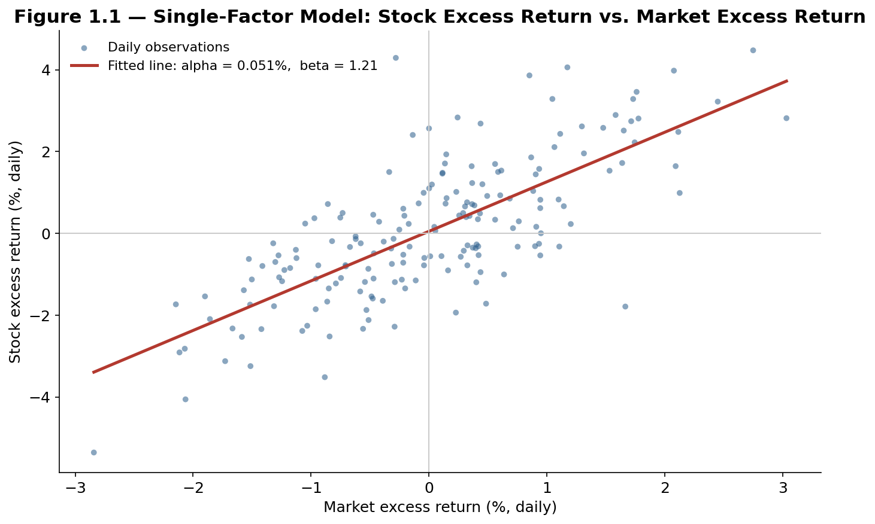
Figure 1.1 — Single-factor model: a regression of a stock's daily excess return on the market's daily excess return recovers both the fitted beta (the slope) and the fitted alpha (the intercept).
Worked example — Suppose a stock has an estimated beta of 1.21 against the market and the market is expected to return 8% above the risk-free rate over the next year. CAPM implies the stock's expected excess return is 1.21 × 8% = 9.68%, so if the risk-free rate is 3%, the stock's expected total return is roughly 12.68%. If the stock's regression also shows a statistically significant intercept — an estimated alpha of, say, 2% per year — that alpha represents return the single-factor model cannot explain through market exposure alone, and is exactly the quantity later, richer factor models in this module are built to explain away.

The economic logic behind CAPM is that the market factor represents undiversifiable risk: an investor can eliminate a stock's idiosyncratic risk by holding a broad portfolio, but cannot eliminate exposure to the market as a whole without giving up expected return altogether, since the market itself is, by definition, the aggregate of everyone's holdings. Beta therefore measures the amount of risk that cannot be diversified away, and expected return should compensate investors only for bearing that residual, undiversifiable portion — not for idiosyncratic risk, which a rational investor should have diversified away for free.

Tip — A single beta is a heavy simplification. It assumes a stock's return responds to only one source of systematic risk, and it assumes that sensitivity is constant through time. Neither assumption holds up well empirically — which is precisely the motivation for the multi-factor models introduced next, and for the rolling, time-varying beta estimation covered in Part 4.

1.3 From One Factor to Many: The General Multi-Factor Model
CAPM's single-factor structure turned out to leave a great deal of return variation unexplained: value stocks, small stocks, and stocks with strong recent momentum all earned average returns that a market-only beta could not account for. Rather than abandon the factor-model framework, researchers extended it — adding more factors to the same additive structure. This is the general K-factor model that underlies everything from this point forward in the module:
Rᵢ,t = αᵢ + βᵢ,1 F1,t + βᵢ,2 F2,t + ... + βᵢ,K FK,t + εᵢ,t
Every term generalizes directly from the single-factor case: Fk,t is the return (or level) of the k-th factor at time t, βᵢ,k is asset i's exposure to that specific factor, and εᵢ,t is still the residual left over after accounting for every factor in the model, ideally uncorrelated across assets once all the genuinely common drivers have been captured. The central design question in building any factor model — the question that separates the three families covered in Part 2 — is simply: where do the factors `F` come from?
- They can be observed macroeconomic variables the modeler chooses in advance — GDP growth, inflation, interest-rate changes (Part 2.1).
- They can be constructed from company characteristics and estimated via cross-sectional regression at each point in time — size, value, industry membership (Part 2.2).
- They can be extracted statistically from the historical covariance of returns themselves, with no economic labels attached at all until the modeler interprets them after the fact (Part 2.3).
All three approaches share the same additive mathematical skeleton above; they differ only in how the factors are defined and how the betas and factor returns are estimated. Part 2 covers each in turn.

Part 2 — Three Families of Factor Models
Every factor model used in practice falls into one of three families, distinguished by where the factors come from and how the model is estimated. This part covers each family's construction, its economic logic, and a worked example, so that later parts of the module — the Fama-French tradition in Part 3 and the estimation techniques in Part 4 — have a common vocabulary to build on.

2.1 Macroeconomic Factor Models
A macroeconomic factor model specifies its factors as observable, economy-wide variables chosen by the modeler in advance of any estimation — for example, unexpected changes in industrial production, inflation, the term spread between long- and short-term interest rates, and the credit spread between corporate and government bonds. The classic example is the Chen–Roll–Ross five-factor macroeconomic model from the 1980s, which tested exactly this set of variables against U.S. stock returns.
Estimation proceeds asset by asset: for each stock or portfolio, its historical return series is regressed on the time series of the chosen macro variables, producing a beta to industrial production, a beta to inflation, a beta to the term spread, and so on. This is a time-series regression, run separately for each asset, in contrast to the cross-sectional approach covered next.
Worked example — An airline stock is regressed against monthly oil-price changes, GDP growth, and the term spread. The resulting betas might show a beta of −1.8 to oil prices (airlines are hurt badly by rising fuel costs), a beta of 2.1 to GDP growth (air travel is highly cyclical), and a near-zero beta to the term spread. A regional utility company, regressed against the same three factors, would likely show close to a zero beta to oil, a low beta to GDP (utility demand is far less cyclical), and a modest positive beta to the term spread, since utilities are often financed with long-term debt. The same macroeconomic factor model reveals two structurally different risk profiles.

Macroeconomic factor models are intuitive and directly interpretable — a beta to "oil price changes" needs no further explanation — which makes them especially useful for scenario analysis and stress testing ("how would this portfolio perform if oil rose 20% and GDP growth fell 2 points?"). Their main limitation is that many macro variables are reported only monthly or quarterly, with long and uneven lags, and are themselves frequently revised after the fact, which makes macroeconomic factor models comparatively slow to estimate and update relative to the two families below.

2.2 Fundamental (Cross-Sectional) Factor Models
A fundamental factor model — sometimes called a cross-sectional factor model — flips the estimation procedure around. Instead of choosing macro time series and running one regression per asset, the modeler chooses a set of observable company characteristics (size, book-to-market ratio, trailing return, debt levels, industry classification) that are known simultaneously for every asset in the universe at a given point in time, standardizes them into exposures, and then runs a single cross-sectional regression of that period's returns on those exposures across all assets. This is repeated at every time step, producing a time series of estimated factor returns, one regression per period rather than one regression per asset.
Rᵢ,t = Σₖ Xᵢ,k,t · Fk,t + εᵢ,t (cross-sectional regression, run separately at each date t)
Here Xᵢ,k,t — the exposure of asset i to factor k at time t — is known directly from the company's characteristics (already standardized, typically as a z-score against the universe), and the regression at each date t solves for the unknown factor returns Fk,t that best explain that period's cross-section of stock returns. This is the reverse of the macroeconomic approach: there, the factor is known and the beta is estimated; here, the exposure is known and the factor return is estimated.
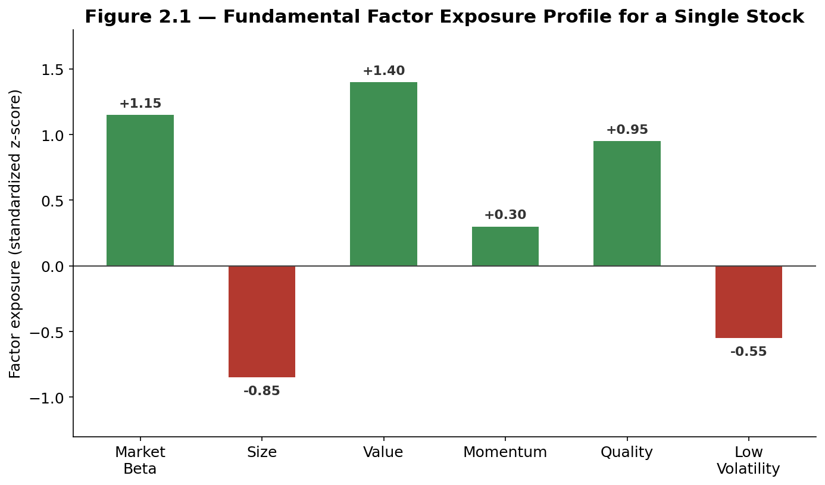
Figure 2.1 — A fundamental factor exposure profile: this hypothetical stock is large-beta, small-cap, deeply undervalued on standard metrics, and moderately high quality, with below-average recent momentum and above-average volatility.
This is the family of model used by essentially every institutional equity risk system — MSCI Barra, Axioma/SimCorp, and Northfield among them — because it updates as fast as the underlying company characteristics and market prices do (daily, in practice), and because its exposures are directly interpretable in the same fundamental language portfolio managers already use to describe stocks.

2.3 Statistical Factor Models
The third family makes no assumption at all about what the factors represent economically. A statistical factor model starts only from the historical covariance matrix of a universe of asset returns and asks a purely mathematical question: what is the smallest number of underlying, mutually uncorrelated series that, combined in different weighted proportions for each asset, can reproduce most of the observed co-movement across all the assets? The dominant technique for answering this is Principal Component Analysis (PCA).
PCA decomposes the covariance matrix of returns into a ranked sequence of orthogonal components, each capturing progressively less of the total variance across the universe. In a broad equity universe, the very first principal component almost always turns out to explain a large share of total variance and to correlate extremely closely with a simple broad market index — which is a striking, purely statistical confirmation of the economic intuition behind CAPM: the single most important source of common variation in stock returns really is "the market." Later components are harder to label and often correspond loosely to recognizable themes such as sector or size effects, but PCA itself assigns them no economic name.
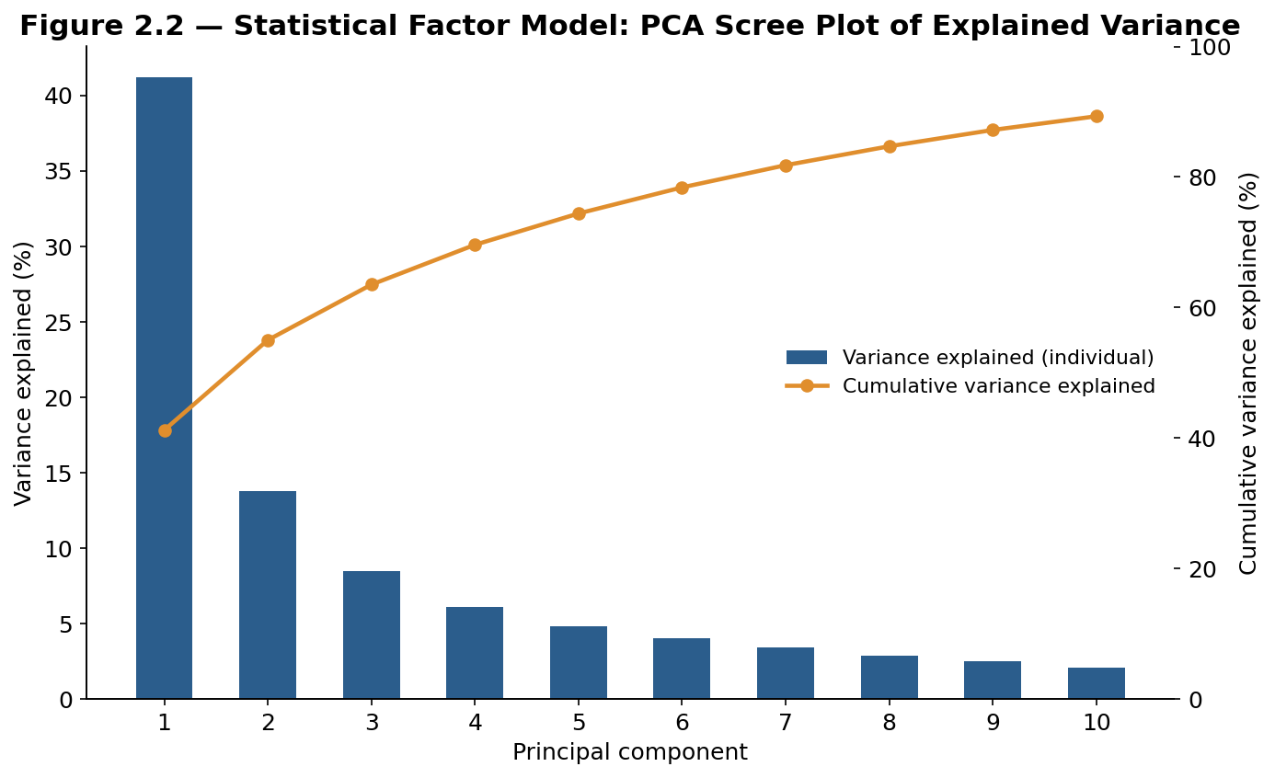
Figure 2.2 — A scree plot from a statistical factor model: the first principal component alone explains roughly 41% of total return variance in this universe, with each subsequent component contributing progressively less.
Tip — A common rule of thumb for deciding how many statistical factors to keep is to look for the "elbow" in the scree plot — the point where additional components start contributing only marginal explanatory power — or to keep enough components to explain a target cumulative share of variance (commonly somewhere between 80% and 95%, depending on the application). Keeping too few components leaves real systematic risk misclassified as idiosyncratic; keeping too many starts fitting sample-specific noise rather than genuine common structure.

Statistical factor models have one major practical advantage over the other two families: they require no prior economic judgment and adapt automatically to whatever structure is actually present in the data, which makes them valuable in asset classes — credit, commodities, emerging markets — where good fundamental or macroeconomic data may be sparse or unreliable. Their major disadvantage is the mirror image of that advantage: because the components are not economically labeled, they are harder to interpret, harder to explain to a portfolio manager or a regulator, and can be unstable, reshuffling their order or composition somewhat as the estimation window rolls forward through time.
Family | Factors defined by | Estimated via | Update speed | Best suited to
Macroeconomic | Chosen economic variables | Time-series regression per asset | Slow (monthly / quarterly) | Scenario analysis, stress testing
Fundamental | Company characteristics | Cross-sectional regression per date | Fast (daily) | Institutional equity risk systems
Statistical | Extracted from covariance (PCA) | Eigen-decomposition | Fast, but unstable labels | Sparse-data asset classes

Part 3 — The Fama-French Tradition and the Factor Zoo
No development in factor-model history has been more influential than the sequence of models built by Eugene Fama and Kenneth French, beginning in 1992–1993. This part traces that lineage — three factors, then four, then five — and ends with the broader phenomenon it triggered across the academic literature, commonly nicknamed the "factor zoo."

3.1 The Fama-French Three-Factor Model
Fama and French observed that CAPM's single market beta left two robust, well-documented patterns in stock returns unexplained: small-capitalization stocks tended to outperform large-capitalization stocks over long periods (the size effect), and stocks with a high book-to-market ratio — statistically "cheap" stocks — tended to outperform stocks with a low book-to-market ratio, or "expensive" stocks, over long periods (the value effect). Rather than treat these as anomalies to CAPM, they proposed adding two new factors built exactly the way a fundamental factor model builds one: as long-short portfolios formed directly on the underlying characteristic.
Rᵢ − Rf = αᵢ + βᵢ,Mkt(Rm − Rf) + βᵢ,SMB · SMB + βᵢ,HML · HML + εᵢ
- SMB (Small Minus Big) — the return of a portfolio long small-cap stocks and short large-cap stocks, isolating the size effect.
- HML (High Minus Low) — the return of a portfolio long high book-to-market ("value") stocks and short low book-to-market ("growth") stocks, isolating the value effect.
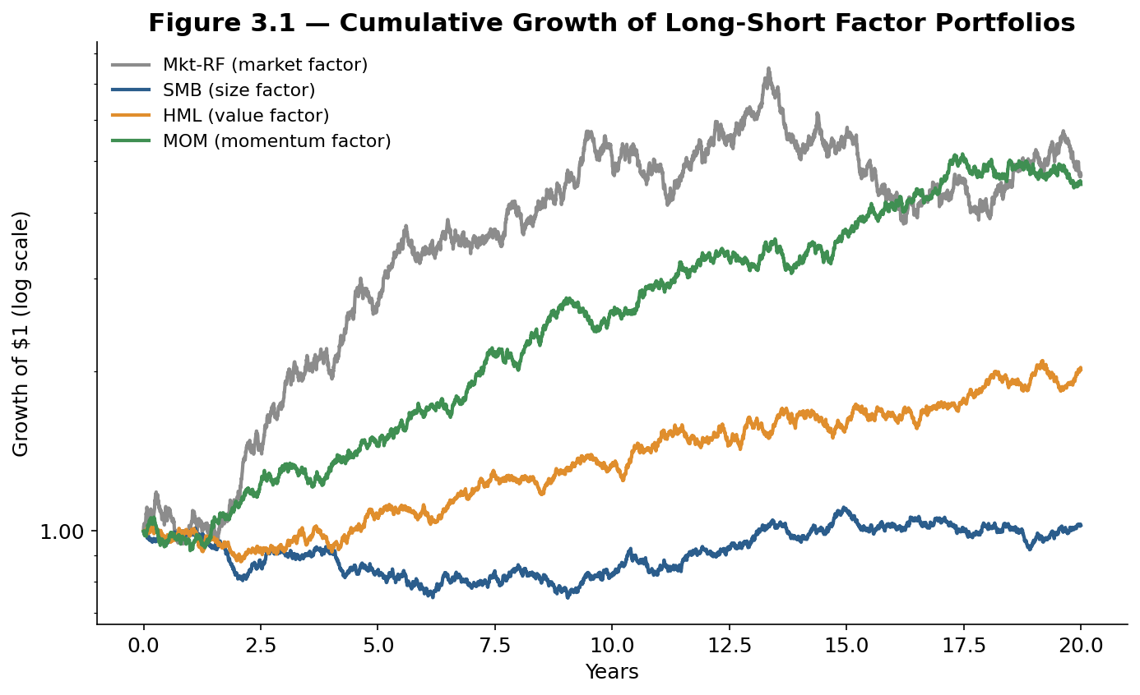
Figure 3.1 — Simulated cumulative growth of $1 invested in each long-short factor portfolio: the market factor dominates over the long run, but size, value, and momentum each contribute a materially different, imperfectly correlated return path.
Worked example — A small-cap value stock might show a market beta of 1.0, an SMB beta of 0.8, and an HML beta of 0.6. If, over the coming year, the market factor is expected to return 7%, SMB is expected to return 2%, and HML is expected to return 3%, the three-factor model's expected excess return is (1.0 × 7%) + (0.8 × 2%) + (0.6 × 3%) = 7% + 1.6% + 1.8% = 10.4% — noticeably higher than the roughly 7% a single-factor CAPM model would have predicted for a stock with the same market beta alone, precisely because CAPM has no way to credit the stock for its additional size and value exposures.

The economic rationale for both new factors remains debated to this day, which is itself an important lesson: a factor can be statistically robust for decades while its underlying cause is still contested. One camp (the risk-based view) argues small and value stocks are genuinely riskier — more exposed to financial distress and economic downturns — and the premium compensates investors for bearing that risk. A second camp (the behavioral view) argues investors systematically overpay for exciting "growth" stocks and underprice boring, distressed-looking "value" stocks, and the premium is a correction of that mispricing rather than compensation for risk at all.

3.2 Momentum and the Carhart Four-Factor Model
In 1997, Mark Carhart extended the three-factor model with a fourth factor built to capture the momentum effect documented by Jegadeesh and Titman — the tendency of stocks that have performed well over the trailing 3–12 months to keep outperforming over the following few months, and vice versa for recent losers (the same effect covered from a strategy-design perspective in the Alpha Research module's treatment of cross-sectional momentum).
Rᵢ − Rf = αᵢ + βᵢ,Mkt(Rm − Rf) + βᵢ,SMB · SMB + βᵢ,HML · HML + βᵢ,MOM · MOM + εᵢ
MOM (sometimes labeled UMD, for "Up Minus Down") is constructed the same way as SMB and HML: long a portfolio of the strongest recent performers, short a portfolio of the weakest recent performers, formed on trailing return and rebalanced periodically. Carhart's original purpose for the model was not primarily asset pricing but performance evaluation: he showed that a large share of what looked like manager skill ("alpha") in mutual fund returns disappeared once a momentum factor was added, because many funds were simply, if unintentionally, tilted toward recent winners. This remains one of the four-factor model's most important uses today — cleaning manager alpha of a well-known, easily replicated factor exposure before crediting it as genuine skill.
Tip — Momentum is unusual among the canonical factors in that it is far harder to explain with a simple risk story than value or size are; the leading explanations remain largely behavioral (underreaction to news, and the slow diffusion of information across investor types), and momentum is also the factor most associated with sudden, sharp crashes when crowded short positions in past losers are forced to unwind — a dynamic explored further in Part 5.2.

3.3 The Fama-French Five-Factor Model and the ‘Factor Zoo’
In 2015, Fama and French themselves extended their original model again, adding two further factors motivated directly by dividend-discount-model logic: profitability and investment.
Rᵢ − Rf = αᵢ + βᵢ,Mkt(Rm − Rf) + βᵢ,SMB · SMB + βᵢ,HML · HML + βᵢ,RMW · RMW + βᵢ,CMA · CMA + εᵢ
- RMW (Robust Minus Weak) — long firms with high operating profitability, short firms with weak profitability.
- CMA (Conservative Minus Aggressive) — long firms that invest conservatively (low asset growth), short firms that invest aggressively (high asset growth).
One motivation for adding these two factors was that, once profitability and investment were controlled for, the original value factor HML lost a meaningful share of its explanatory power — some of what looked like a pure value effect was, statistically, better described as a profitability and investment effect operating through valuation ratios. This is itself a useful lesson in factor construction: factors built on related underlying characteristics are often correlated with each other, and the presence of one factor changes how much independent explanatory power any other factor appears to have — a theme returned to in Part 5.3 on multicollinearity.
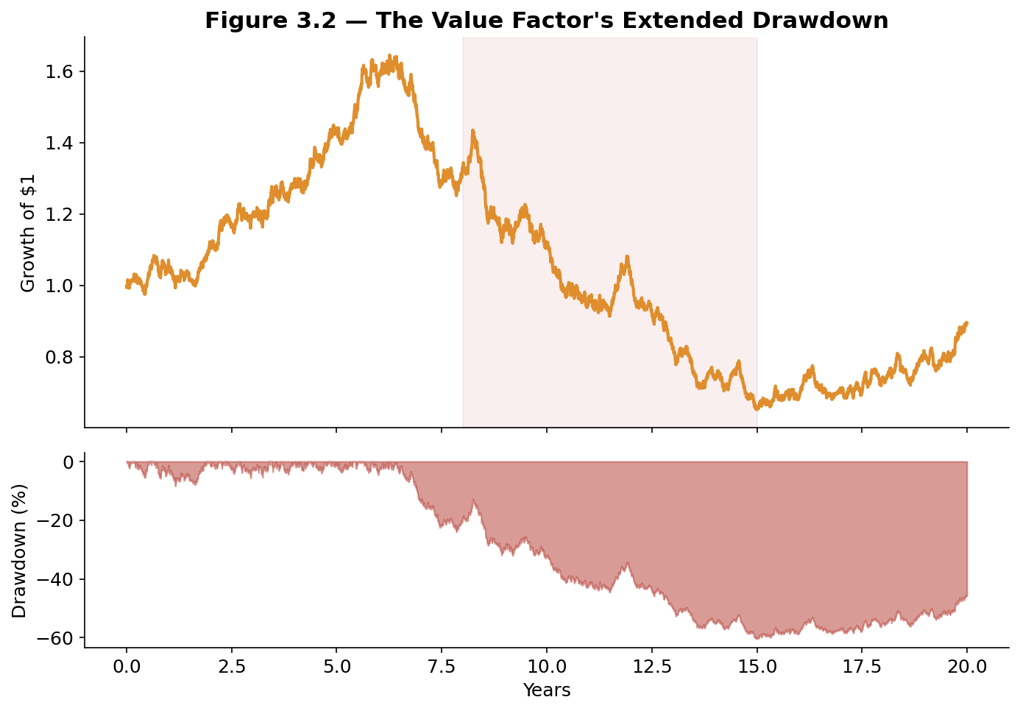
Figure 3.2 — A simulated illustration of the value factor's real-world experience from roughly 2007 to the early 2020s: an extended multi-year drawdown that led many practitioners to publicly question whether the value premium still existed.
The five-factor model's publication also crystallized a broader phenomenon that had been building for years: the academic finance literature had, by the mid-2010s, identified several hundred distinct variables each claimed to "explain" the cross-section of stock returns — a body of research now commonly called the factor zoo. Campbell Harvey, Yan Liu, and Heqing Zhu's influential 2016 survey argued that, given how many variables researchers had tested against the same relatively short history of U.S. stock returns, the conventional statistical significance threshold (a t-statistic above roughly 2.0) was far too lenient, and proposed considerably stricter thresholds to account for the sheer number of factors that had, in effect, been tried.
Common mistake — Treating every factor in the academic literature as equally credible. A factor with a plausible economic story, evidence across multiple independent markets and time periods, and a stable sign is in an entirely different category of reliability from a factor discovered by testing hundreds of variables against one dataset and reporting only the ones that cleared a conventional significance bar — even though both may show an identical-looking t-statistic in the paper that introduced them.

Part 4 — Estimating and Using Factor Models
Parts 1 through 3 covered what factor models are and where their factors come from. Part 4 turns to the practical mechanics: how factor exposures are actually estimated from data, how a factor model is used to decompose risk, and how that decomposition feeds directly into portfolio construction, hedging, and performance attribution.

4.1 Estimating Factor Exposures via Regression
For any given factor model, the standard way to estimate an asset's exposure to a single factor is an ordinary least squares regression of the asset's historical returns on the factor's historical returns; with multiple factors, this generalizes to a multiple regression in which every factor is included simultaneously, so that each estimated beta reflects that factor's contribution after controlling for the others.
β̂ = Cov(Rᵢ, F) / Var(F) (single-factor case; the multi-factor case solves the analogous matrix equation)
Three practical choices dominate how reliable this estimate turns out to be, and each involves a genuine trade-off rather than a single correct answer:
- Estimation window length — A longer window (say, five years of monthly data) produces a more statistically precise estimate but assumes the true exposure has been stable over that whole period, which is often false for a company that has changed its business mix, leverage, or size.
- Return frequency — Daily data gives far more observations than monthly data for the same calendar window, improving statistical precision, but daily returns are noisier and more exposed to microstructure effects such as bid-ask bounce and non-synchronous trading.
- Static vs. rolling estimation — A single fixed-window regression produces one beta for the whole period; a rolling regression, re-estimated at every date over a moving window, captures the fact that true exposures drift over time, at the cost of adding estimation noise to each individual snapshot.
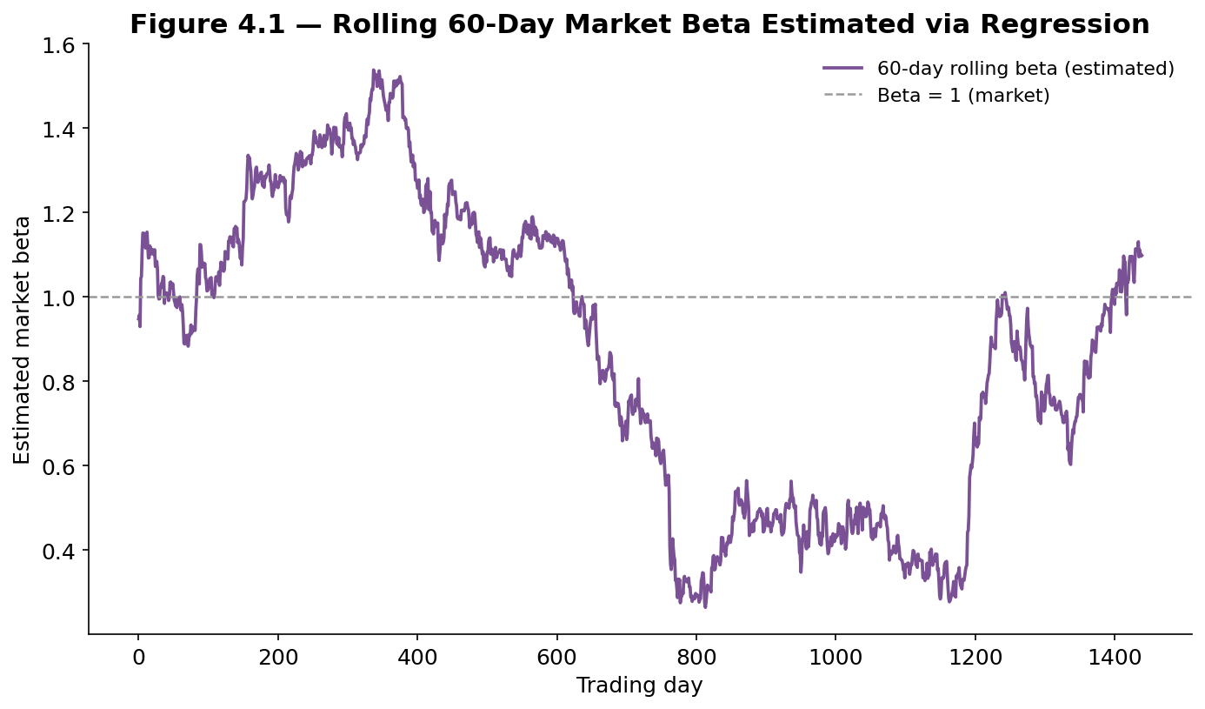
Figure 4.1 — A rolling 60-day regression beta estimated from simulated data: the asset's true underlying market sensitivity drifts over time, and only a rolling estimation window captures that drift; a single full-sample beta would report one number that was never actually true at any specific point in time.
Tip — R² from a factor-model regression tells you how much of an asset's variance the model explains, but it says nothing about whether the factors are the right factors or whether the betas are stable. A high R² with unstable, rolling betas can be more dangerous for risk management than a moderate R² with stable ones, because it invites false confidence in a snapshot exposure that may already be out of date by the time it is used.

4.2 Risk Decomposition: Factor Risk vs. Idiosyncratic Risk
Once an asset's factor exposures are estimated, its total return variance can be split cleanly into a systematic (factor) component and an idiosyncratic (residual) component:
Var(Rᵢ) = Σₖ Σₗ βᵢ,k βᵢ,l Cov(Fk, Fl) + Var(εᵢ)
The first term aggregates every factor's variance and every pairwise covariance between factors, each weighted by the relevant pair of betas; the second term is simply the variance of the leftover residual. The identical logic extends directly from a single asset to an entire portfolio, by replacing each asset's betas with the portfolio's aggregate, position-weighted exposure to each factor. This is exactly the calculation institutional risk systems run every day to answer the question "where is this portfolio's risk actually coming from?" — a question that simple position counts or sector labels cannot answer on their own.
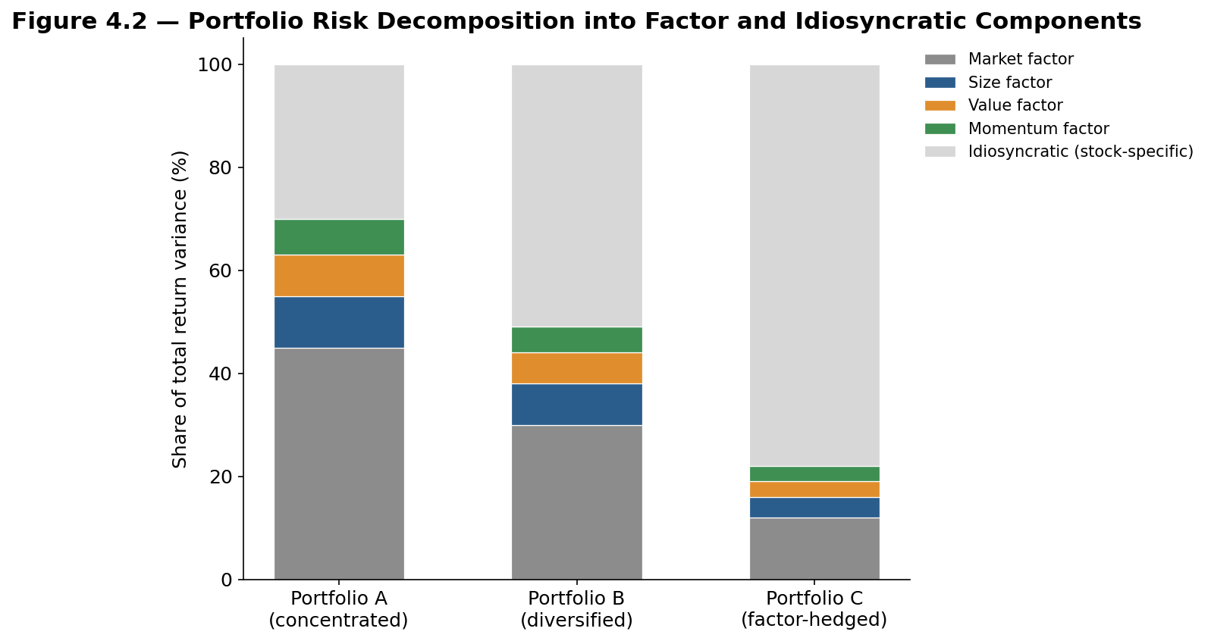
Figure 4.2 — Three portfolios with identical stock counts can carry very different risk structures: a concentrated portfolio, a broadly diversified one, and one deliberately factor-hedged to strip out common exposures and leave mostly idiosyncratic risk.
Worked example — Portfolio A above holds 20 concentrated positions and derives roughly 70% of its return variance from four common factors, leaving only 30% idiosyncratic — meaning most of its risk will move in lockstep with the broad market and a handful of style factors, regardless of how carefully the individual stocks were chosen. Portfolio C, hedged to strip out the same four factor exposures, derives roughly 78% of its remaining variance from stock-specific risk — a portfolio manager running Portfolio C is making a far more concentrated bet on individual stock-picking skill, for better or worse, than the manager running Portfolio A realizes they are making.

4.3 Applications: Portfolio Construction, Hedging, and Attribution
The same underlying decomposition supports three distinct, everyday uses of a factor model in a working investment process:
- Portfolio construction — A portfolio's aggregate factor exposures can be targeted directly, by optimizing position weights so the resulting book has a desired exposure profile (for example, market-neutral, or overweight quality and underweight momentum) rather than leaving exposures as an accidental byproduct of individual stock selection.
- Hedging — If a portfolio manager wants exposure to a specific idea (say, an individual stock's idiosyncratic story) without the unwanted systematic exposures that come bundled with it, they can short an appropriately-weighted factor portfolio (or an index/ETF proxy for it) to neutralize the unwanted betas, leaving a cleaner, more targeted bet.
- Performance attribution — After the fact, a realized portfolio return can be decomposed into the portion explained by each factor's realized return, times the portfolio's exposure to it, plus a residual alpha — exactly the calculation Carhart used to show that much of what looked like mutual-fund manager skill was, in fact, a momentum tilt.
Together, these three applications are why factor models sit at the center of institutional portfolio management rather than being a purely academic curiosity: they are simultaneously the tool used to build a portfolio, the tool used to manage its risk while it is held, and the tool used to judge how well it performed afterward.

Part 5 — Factor Investing in Practice
The final part turns from the mechanics of factor models to how they are actually used — and misused — in live portfolios: the rise of factor investing as a product category, the risk that a factor becomes so widely held that its own popularity destabilizes it, and the statistical pitfalls that most commonly trip up newcomers building their first factor model.

5.1 Smart Beta and Factor Investing
If a factor like value, quality, or momentum earns a persistent long-run premium, an obvious next step is to build an investment product that delivers exposure to that factor directly and cheaply, rather than paying an active manager to (imperfectly, and expensively) deliver something similar as a byproduct of discretionary stock-picking. This is the idea behind smart beta: transparent, rules-based portfolios constructed explicitly to harvest one or more specific, well-documented factor premia, typically at a fraction of the cost of active management.
Smart beta products have grown into a large share of the ETF and index-fund industry, spanning single-factor funds (a pure value fund, a pure low-volatility fund) and multi-factor funds that blend several factors together, often with the explicit goal of diversifying across factors whose returns are imperfectly correlated with each other — since, as Figure 3.1 illustrated, the market, size, value, and momentum factors do not move in lockstep, blending them can smooth the ride even when no single factor is reliably the best performer in any given year.

5.2 Factor Crowding, Timing, and Cyclicality
A factor's popularity is a double-edged sword. As more capital is deployed specifically to capture a given factor premium, two things tend to happen: the premium itself can compress, as increased demand for the same characteristic (buying cheap stocks, for instance) bids up their prices and narrows the very valuation gap the strategy was designed to exploit; and the factor becomes structurally more fragile, because a large number of participants holding highly similar positions can be forced to sell at the same time if conditions change — a dynamic known as factor crowding.
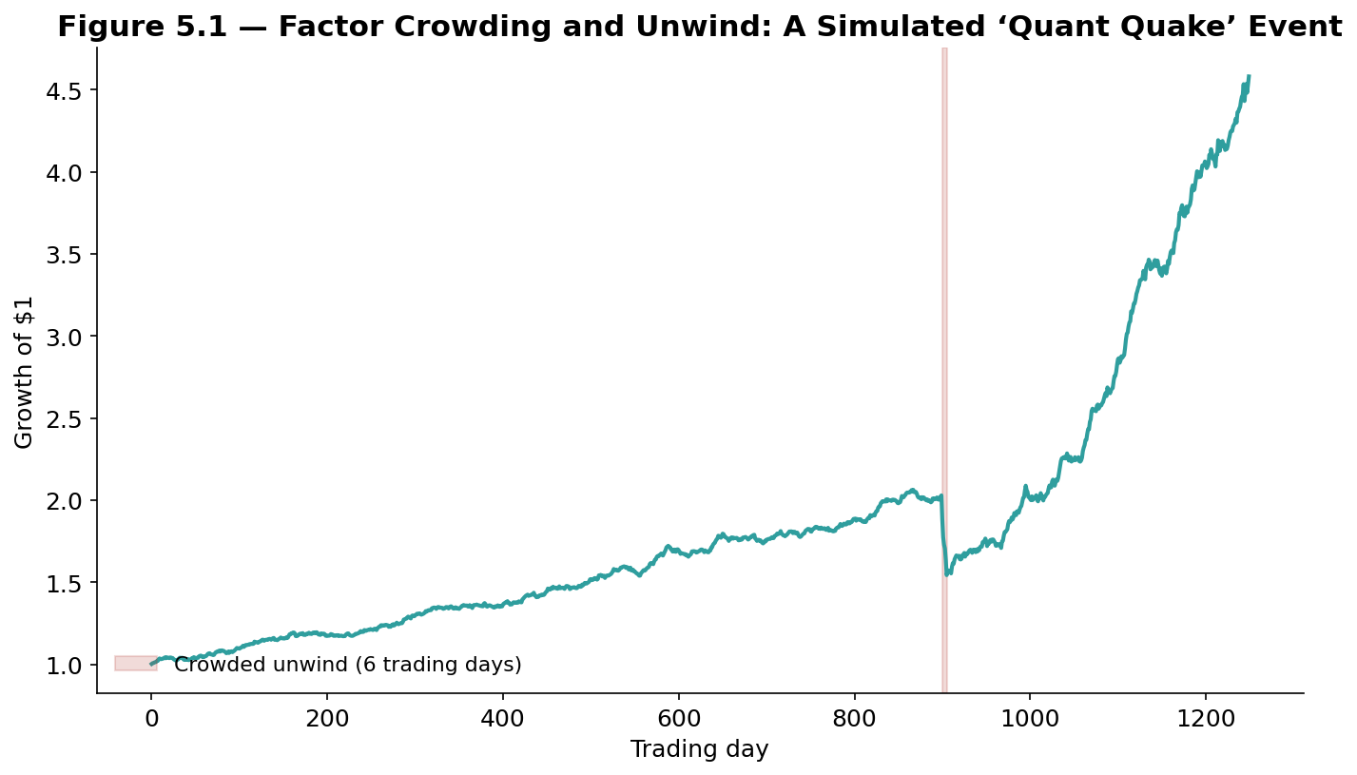
Figure 5.1 — A simulated illustration of a crowded factor unwind: a steady, low-volatility return pattern gives way to a sudden, sharp multi-day loss as many similarly-positioned participants attempt to exit at once, before the factor stabilizes at a lower level.
The most widely cited real-world example is the August 2007 "quant quake," in which numerous quantitative equity funds pursuing similar value and momentum-style strategies suffered severe, highly correlated losses over just a few trading days, apparently triggered by one or more large funds deleveraging and forcing correlated selling across the whole crowded trade — even though nothing had fundamentally changed about the companies held in any individual portfolio. The event has since become the canonical cautionary tale for why understanding who else holds a similar factor exposure matters as much as understanding the factor's long-run average premium.
This crowding dynamic is closely related to the idea of factor timing — attempting to over- or under-weight specific factors based on where they sit in their own cycle of popularity, valuation, or recent performance, in the same spirit as market timing applied to individual factors rather than to the market as a whole. Factor timing remains genuinely contested among practitioners: some evidence suggests factors do exhibit exploitable cyclicality (a factor that has become expensive relative to its own history tends to underperform subsequently), but factor timing strategies are also exposed to exactly the same overfitting risks discussed next, and a poorly designed timing rule can easily destroy more value than it adds.
Tip — A useful discipline before trading any factor at scale is to ask explicitly how crowded it currently appears — proxies include the factor's recent valuation spread relative to its own history, aggregate estimates of assets managed against it, and its recent correlation with other well-known factors — rather than relying purely on the factor's long-run historical Sharpe ratio, which says nothing about who else is positioned the same way today.

5.3 Pitfalls: Overfitting, Multicollinearity, and Data Mining
Three closely related statistical pitfalls account for the great majority of poorly built factor models, and each is worth understanding on its own terms.
- Overfitting — Adding more and more factors to a model will always increase its in-sample R², simply because each additional variable gives the regression more freedom to fit the noise in the historical sample, whether or not that variable has any genuine explanatory power going forward; a model selected purely to maximize in-sample fit will systematically disappoint out of sample.
- Multicollinearity — When two or more factors are themselves highly correlated (value and profitability, for instance, or size and low-volatility), their individual regression coefficients become statistically unstable — small changes in the sample period or the exact factor definition can flip a coefficient's sign or dramatically change its magnitude, even though the combined explanatory power of the correlated factors together remains stable.
- Data mining (the "factor zoo" problem revisited) — Testing a very large number of candidate factors against the same historical dataset and reporting only the ones that clear a conventional significance threshold guarantees that some purely spurious factors will pass that bar by chance alone; the more variables tested, the more of this false-positive contamination should be expected, which is exactly the concern Harvey, Liu, and Zhu raised about the academic factor literature in Part 3.3.
Common mistake — Building a factor model with ten or more factors because each one individually shows a statistically significant coefficient in isolation, without checking pairwise correlations between the candidate factors first. In a model with severe multicollinearity, individual coefficients can be almost meaningless even while the model's overall fit looks excellent — the fix is not to add more factors but to test the correlation structure of candidate factors before including them, and to prefer a smaller set of well-understood, economically distinct factors over a larger set of statistically similar ones.

Practical Exercise
Choose an equity universe of at least 50 stocks with several years of price history. Estimate each stock's single-factor CAPM beta against a broad market index, then estimate a simple three-factor model (market, a size proxy built from market capitalization, and a value proxy built from a valuation ratio you construct yourself) via monthly cross-sectional regression. Compare the R² of the single-factor and three-factor models, and check the checklist below before drawing any conclusions.

Factor-model validation checklist
- Economic rationale stated first — write one paragraph on why each factor you include should earn a premium before looking at any regression output.
- Correlation check — compute the pairwise correlation between every candidate factor before running the regression, and flag any pair above roughly 0.6 for closer scrutiny.
- Out-of-sample split — estimate betas on an earlier sub-period and test the model's explanatory power on a later, untouched sub-period.
- Stability check — re-estimate the model on a rolling window and check whether the betas and factor returns are reasonably stable, or whether they swing wildly from period to period.
- Residual check — examine whether the leftover residuals are still correlated across stocks within the same sector or theme, which would indicate a missing factor rather than genuine idiosyncratic risk.
# Skeleton for the practical exercise

# 1. State the economic rationale for each factor (as a comment)
# rationale = "..."

def cross_sectional_regression(returns_t, exposures_t):
# returns_t: vector of stock returns at date t
# exposures_t: matrix of standardized factor exposures at date t
factor_returns_t = ols_fit(returns_t, exposures_t)
return factor_returns_t

def decompose_risk(betas, factor_cov, residual_var):
systematic_var = betas.T @ factor_cov @ betas
total_var = systematic_var + residual_var
return systematic_var / total_var # share of variance from factors

# Evaluate: R-squared (single- vs multi-factor), factor correlation
# matrix, out-of-sample stability, and a written note on which
# factors you would drop due to multicollinearity.

Common Beginner Mistakes
- Treating every statistically significant factor as a guaranteed source of return — a factor model describes historical covariance structure, not a promise about the future; see the prerequisite gate at the start of this module.
- Ignoring multicollinearity between candidate factors — adding correlated factors without checking their relationship first, then over-interpreting individually unstable coefficients.
- Using a single, static beta estimated over too long a window — ignoring that a company's true factor exposures typically drift as its business, leverage, and size change over time.
- Confusing a high R² with a correctly specified model — a model can explain a great deal of in-sample variance while still being built on factors that are unstable, overfit, or economically meaningless.
- Ignoring how crowded a factor has become — evaluating a factor purely on its long-run historical Sharpe ratio, without asking who else is currently positioned to capture the same premium.

Advanced Extensions
The following are Level 3–5 topics, introduced here only by name so you know what to look for when you reach them:
- Conditional and regime-dependent factor models — allowing factor exposures and factor premia themselves to vary with the macroeconomic or volatility regime, rather than assuming a single fixed structure applies at all times.
- Bayesian and shrinkage estimation of factor exposures — blending a stock's own noisy estimated beta with a cross-sectional prior (for example, its industry's average beta) to produce a more stable estimate, especially for stocks with short or noisy return histories.
- Machine-learning factor models — using nonlinear methods (random forests, neural networks) to discover factor-like structure directly from raw characteristic and price data, at the cost of the direct interpretability that makes traditional factor models so widely used in risk management.

Professional Applications
- Institutional risk systems — MSCI Barra, Axioma (now part of SimCorp), and Northfield are, structurally, large fundamental factor models sold as a service to asset managers for daily portfolio risk decomposition, exactly as described in Part 4.
- Smart beta and factor ETFs — the asset-management industry now offers transparent, rules-based fund products built to deliver value, quality, momentum, low-volatility, and multi-factor blended exposures directly to end investors, as covered in Part 5.1.
- Quantitative equity portfolio construction — systematic long-short and long-only equity managers use factor models both to size intended bets and to neutralize unintended exposures that would otherwise dilute or distort their core investment thesis.

Where to Go Next
This module covered factor models from the single-factor CAPM case through the general multi-factor framework, the three families of model construction, the Fama-French lineage, and the practical estimation and application techniques used throughout the industry today. The Alpha Research module's Strategy Families guide returns to several of these same factors — value, quality, momentum, carry — from a signal-construction perspective rather than a risk-decomposition one; the Risk Metrics module builds directly on Part 4's risk-decomposition framework to cover portfolio-level risk measurement in full depth; and the Portfolio Construction module covers the optimization techniques that turn a set of target factor exposures into an actual set of tradeable positions.

